# GOVT. MODEL ENGINEERING COLLEGE, THRIKKAKARA

*“Evolve into academy of excellence to serve the knowledge society”*

### (Managed by IHRD, A Govt. of Kerala Undertaking)



**DEPARTMENT OF ELECTRONICS ENGINEERING ECL 332 COMMUNICATION ENGINEERING LAB MANUAL**

**2019 SCHEME**

# GOVT. MODEL ENGINEERING COLLEGE, THRIKKAKARA

*“Evolve into academy of excellence to serve the knowledge society”* **(Managed by IHRD, A Govt. of Kerala Undertaking) DEPARTMENT OF ELECTRONICS ENGINEERING**



### ECL 332 COMMUNICATION ENGINEERING LAB



NAME…………………………………………………………………………………

BRANCH……………………………………………………………………………....

SEMESTER……………………………………ROLL NO………………………….

*Certified that this is the Bonafide work done by*

………………………………………………………………………………………………….

***Staff-in-Charge Head of the Department***

Register No……………………… Thrikkakara

Year & Month…………………………………. Date……………………….

### CONTENTS

|  |  |  |  |  |
| --- | --- | --- | --- | --- |
| **Part** | **Sl.**  **No.** | **Title** | **Page No.** | **Remarks** |
| **A** | 1 | BPSK Generation and Detection | 1 |  |
| 2 | Study of CMOS PLL IC CD4046 | 4 |  |
| 3 | FM Modulation and Detection using PLL | 8 |  |
| **B** | 4 | Error Performance of BPSK | 12 |  |
| 5 | Error Performance of QPSK | 18 |  |
| 6 | Performance of Waveform Coding Using PCM | 26 |  |
| 7 | Pulse Shaping and Matched Filters | 34 |  |
| 8 | Eye Diagram | 44 |  |
| **C** | 9 | Familiarisation with Software Defined Radio | 48 |  |
| 10 | FM Reception Using SDR | 60 |  |

Date: 30.01.24 Experiment No: 01

# PART - A

## BPSK GENERATION AND DETECTION

**AIM**:

To design and set up a Binary Phase Shift Keying (BPSK) generator.

## COMPONENTS AND EQUIPMENTS REQUIRED:

Analog switch CD4016, IC 741, IC 7404, signal generator, resistor, power supply, breadboard, CRO etc.

## THEORY:

In the BPSK modulation system the phase of the carrier wave is inverted according to the logic level of the input data. When the data is at logic one level, the sinusoid has one fixed phase and when the data is at the other level, the phase of the sinusoid changes. BPSK and BFSK signals have a constant envelope and hence they are less susceptible to noise.

Two switches inside the quad analog switch CD4016 are used in the circuit. Op- amp is used to invert the phase of the input sine wave.

## PROCEDURE:

1. Set up the circuit on bread board and switch on power supply and signal generators.
2. Feed the sine wave and clock from the signal generator.
3. Keep the clock frequency lower than the sine wave frequency and observe the output.

## DESIGN:

Gain of inverting amplifier, A= -Rf/R1

Let the gain be -1, so that the ratio Rf/R1=1.Take R1=Rf=4.7K

## Circuit Diagram

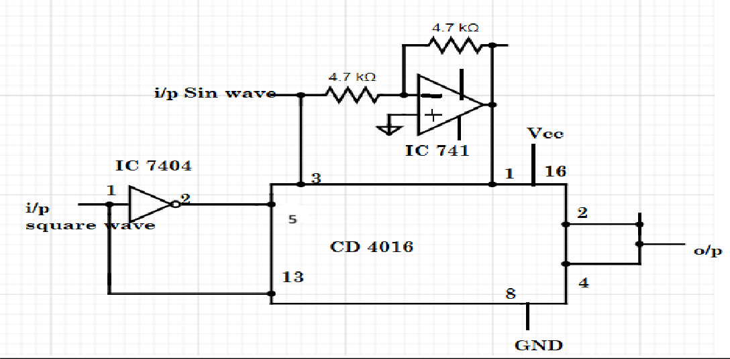

**Demodulator Circuit**

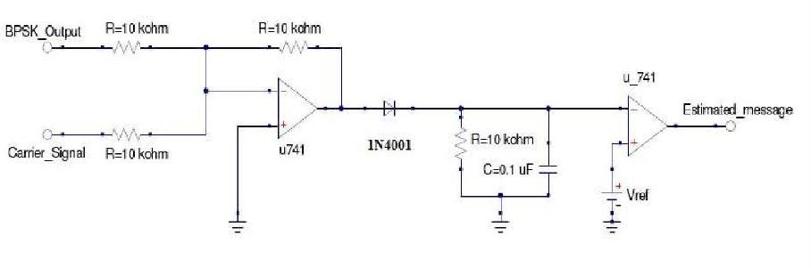

## OUTPUT WAVEFORMS:

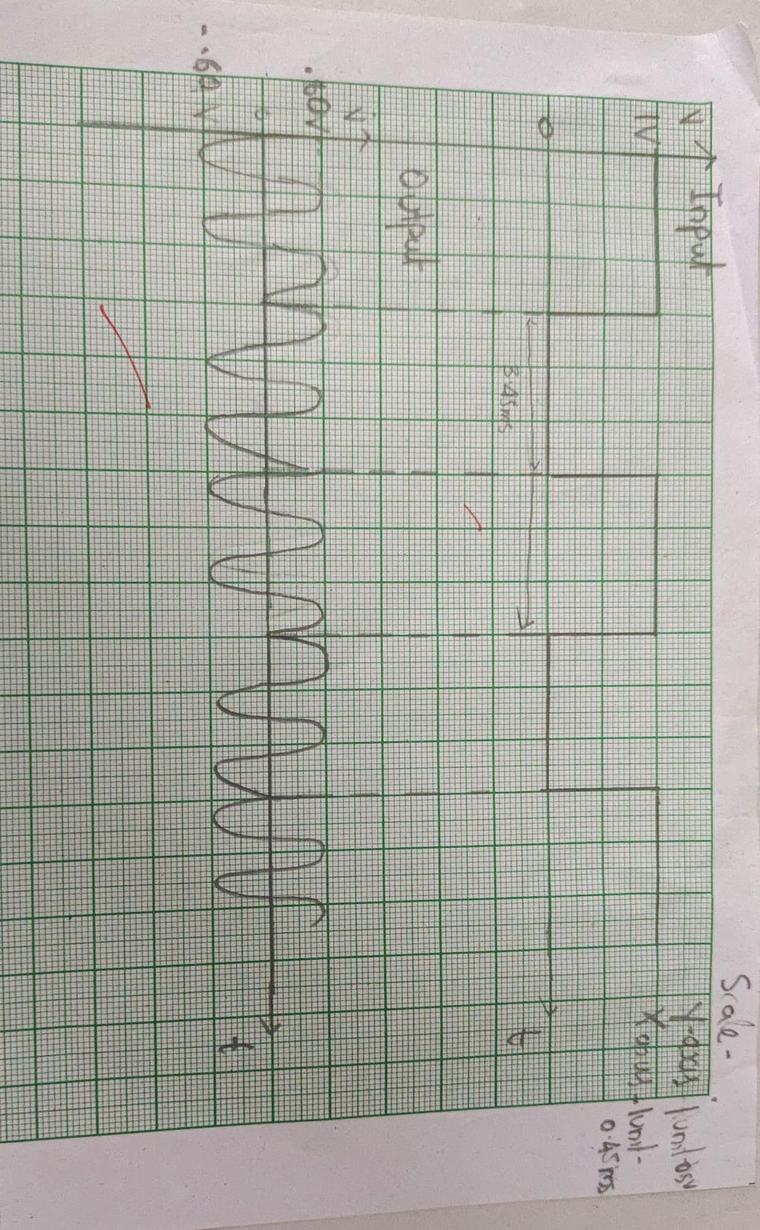

**RESULT:**

BPSK modulator and detector were implemented.

Date: 06.02.24 Experiment No: 02

## STUDY OF CMOS PLL

**AIM:**

To familiarize with CMOS PLL IC CD4046A and study its functional characteristics.

## COMPONENTS REQUIRED:

PLL IC, Capacitors, Oscilloscope, Function Generator, resistors, Bread board, DC Power supply, Connector wires.

## THEORY:

If a voice or music (i.e., modulating signal) is applied to the VCO instead of digital data, the oscillator's frequency will move or modulate with the voice or music, this is frequency modulation "FM". It's simply moving the frequency in relation to some input voltage which also represents a voltage to frequency conversion.

PLL is a circuit designed to synchronize with an incoming signal and remain in synchronization despite the incoming signal variations. PLL mainly consists of the phase detector, a LPF and a VCO. Phase detector provides a DC Voltage proportional to the difference between the inputs. LPF removes high frequency noise. The DC voltage controls the VCO frequency which is then fed back and compared with input frequency and automatically gets itself equal to input frequency.

IC 4046-A is a silicon gate CMOS device which has pins compatible with 4046-B. It consists of a VCO and a three-phase gate. Large signals can be connected directly to the signal inputs of the PLL while series capacitor is used to couple the signal inputs to connect the small signals.

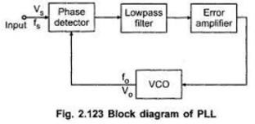

## DESIGN:

Centre frequency is given by fo = 1/2R1(C1+32PF) at VDD 5V Let the required fo= 10 kHz. Let R1= 100kHz.

Then C1= 500 pF use 470 pF.

Capture range 2fc= (1/ π) *(2 πf2/R3C2)1/2

Let the captured range be 800 Hz. Take R3= 100kΩ. Then C2= 0.1 μF.

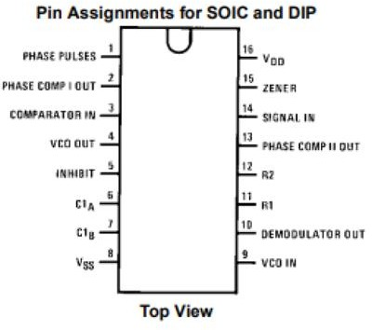

## CIRCUIT:

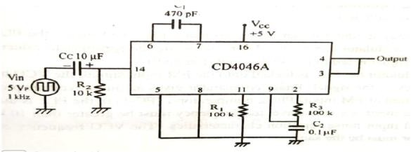

**WAVEFORM:**

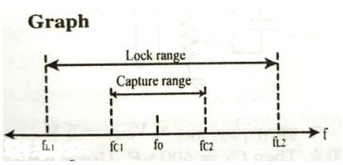

## PROCEDURE:

* 1. Let the circuit and observe the free running frequency f0.
  2. Feed a square pulse input signal and its frequency from 100 Hz to 1 MHz and note down fc1 and fL2.
  3. Decrease the frequency from high value to low value and note down fc2 and fL1.
  4. Calculate capture range fc = fc2 - fc1 and lock range fL= fL2 – fL1.

## RESULT:

Familiarized with CMOS PLL IC 4046A and studied its functional characteristics. Free running frequency, f0 = 9.59 KHz

Lock range=7-17.03KHz Capture range =10.4KHz

Date: 13.02.24 Experiment No: 03

## FM MODULATION AND DETECTION USING PLL

**AIM:**

To design and set up FM Modulation and Detection using PLL ICs.

## COMPONENTS REQUIRED:

PLL IC, Capacitors, Oscilloscope, Function Generator, resistors, Bread board, Connector wires

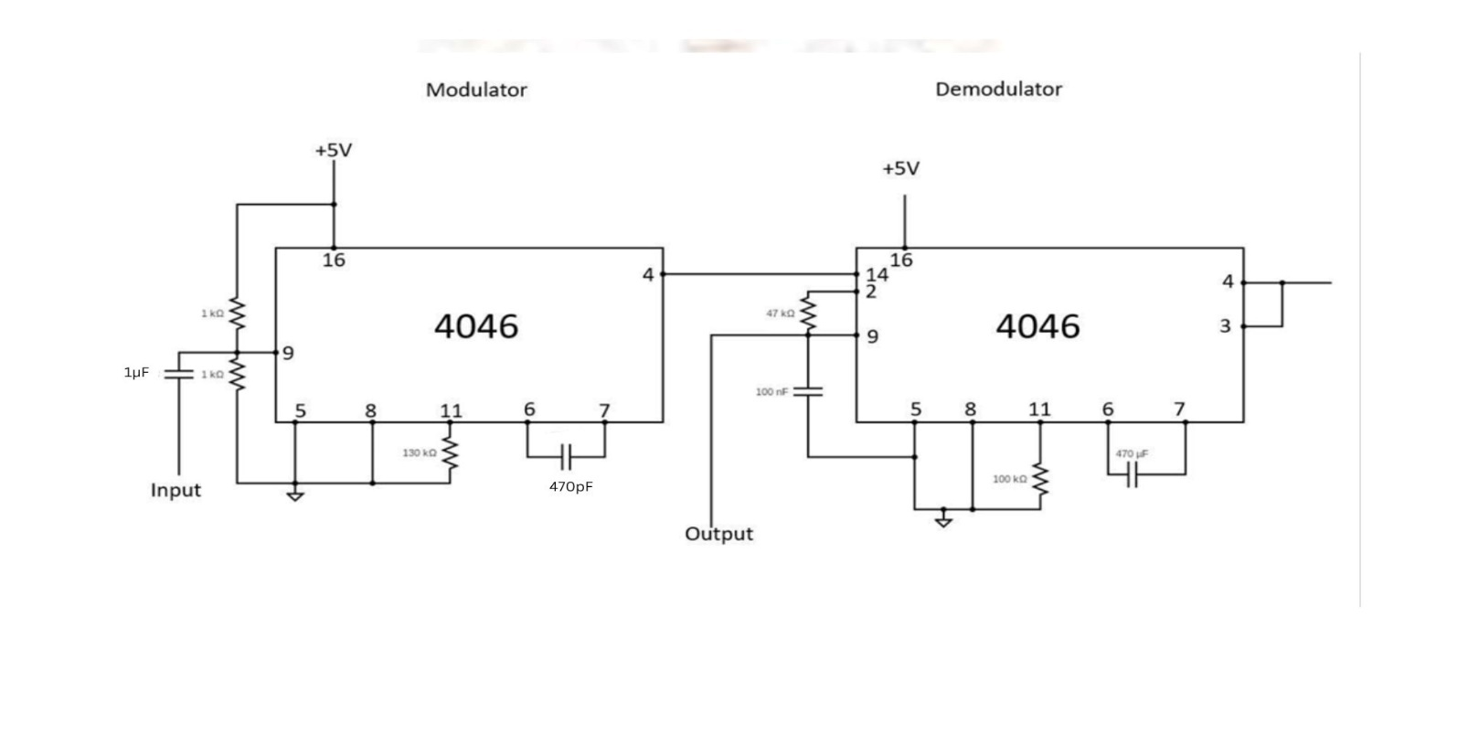

## WAVEFORMS:

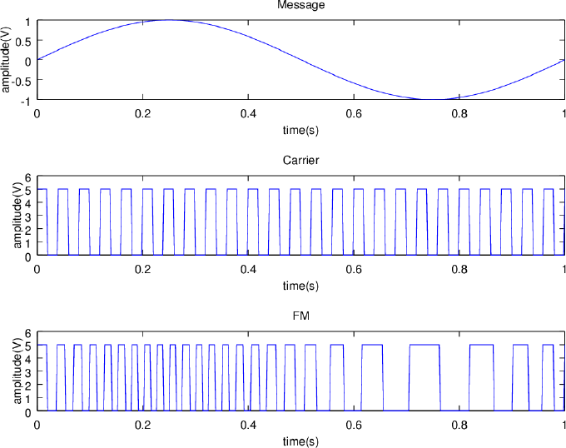

### THEORY:

A phase-locked loop or phase lock loop (PLL) is a control system that tries to generate

an output signal whose phase is related to the phase of the input "reference" signal. It is an electronic circuit consisting of a variable frequency oscillator and a phase detector. This circuit compares the phase of the input signal with the phase of the signal derived from its output oscillator and adjusts the frequency of its oscillator to keep the phases matched. The signal from the phase detector is used to control the oscillator in a feedback loop. Frequency is the derivative of phase. Keeping the input and output phase in lock step implies keeping the input and output frequencies in lock step. Consequently, a phase-locked loop can track an input frequency, or it can generate a frequency that is a multiple of the input frequency. The former property is used for demodulation, and the latter property is used for indirect frequency synthesis. Phase-locked loops are widely used in radio, telecommunications, computers and other electronic applications. They may generate stable frequencies, recover a signal from a noisy communication channel, or distribute clock timing pulses in digital logic designs such as microprocessors. Since a single integrated circuit can provide a complete phase-locked-loop building block, the technique is widely used in modern electronic devices, with output frequencies from a fraction of a Hertz upto many Giga Hertz. When the input frequency is less than fL1, PLL is neither in lock nor in capture, and will be in free running state generating center frequency fO. When input frequency reaches fC1, VCO frequency becomes equal to input frequency, or VCO captures input frequency. If the input frequency increases, VCO frequency follows the input frequency upto the limit of fL2. If input frequency further increases, VCO frequency becomes center frequency f0. If the input frequency is reduced, VCO frequency becomes equal to input frequency only at fC2. If input frequency further If input frequency further decreases, VCO frequency follows input frequency only up to fL1. If input frequency is further decreased, VCO frequency retains original center frequency fo. The frequency range fL2 – fL1 can be defined as the lock range, in which PLL keeps lock with input frequency. The frequency range fC2 – fC1 is called capture range, in which PLL is able to capture the input frequency.

If a voice or music (i.e., modulating signal) is applied to the VCO instead of digital data, the oscillator's frequency will move or modulate with the voice or music, this is frequency modulation "FM". It's simply moving the frequency in relation to some input voltage which also represents a voltage to frequency conversion.

The VCO part of this IC is configured for the same free running frequency as that of the modulator IC. One of the phase detector inputs is fed with the modulated FM signal and the other input of the phase detector is fed with the VCO output after filtering out high frequency components. The phase variation between the two will be corresponding to the message which was used for modulation. The PD output is passed through an emitter follower internally to the demodulated output pin. The output from this pin may contain high frequency ripples which may be eliminated by proper filtering to obtain the actual message.

### PROCEDURE:

1. Find the lock& capture range of each IC and then do the connections.
2. Give the input modulating signal. Note it.
3. Plot the output waveforms of each ICs.

**OUTPUT WAVEFORMS:**

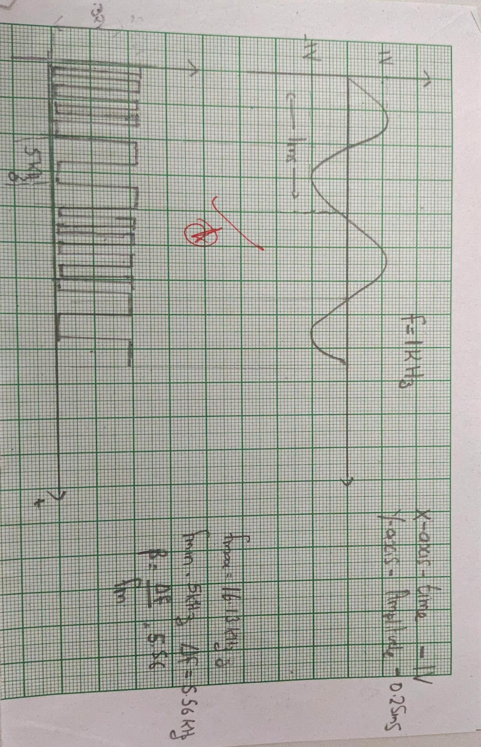

## RESULT:

An FM modulator & detector circuits are set up and the waveforms are plotted.

|  |  |
| --- | --- |
| Centre frequency | 9.59 KHz |
| Lower lock range | 7.9 KHz |
| Lower capture range | 8.7 KHz |
| Upper capture range | 10.4 KHz |
| Upper lock range | 16.13 KHz |
| β | 5.56 |

Date: 02.03.24 Experiment No: 04

# PART - B

## ERROR PERFORMANCE OF BPSK

**AIM:**

1. To generate a string of message bits.
2. To encode using BPSK with energy per bit Eb and represent it using points in a signal-space.
3. To simulate transmission of the BPSK modulated signal via an AWGN channel with variance N0/2.
4. To detect using an ML decoder and plot the probability of error as a function of SNR per bit Eb/N0.

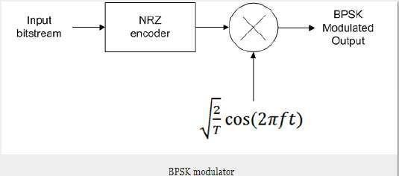

## THEORY:

**Phase Shift Keying** is the digital modulation technique in which the phase of the carrier signal is changed by varying the sine and cosine inputs at a particular time. PSK is widely used for wireless

LANs, bio-metric, contactless operations, along with RFID and Bluetooth communications.

Binary Phase Shift Keying BPSK is also called as 2-phase PSK or Phase Reversal Keying. In this technique, the sine wave carrier takes two phase reversals such as 0° and 180°. BPSK is basically a Double Side Band Suppressed Carrier DSBSC modulation scheme, for message being the digital information. Figure 1 shows the block diagram of BPSK modulator. Figure 2. Shows the BPSK in time domain and frequency domain. Figure 3 shows the block diagram of BPSK receiver.

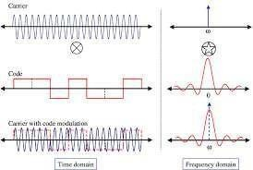

Fig 2. Waveforms

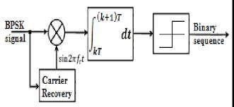

Fig 3. BPSK detector

Bit error rate (BER) of a communication system is defined as the ratio of number of error bits and total number of bits transmitted during a specific period. It is the likelihood that a single error bit will occur within received bits, independent of rate of transmission. For any given modulation, the BER is normally expressed in terms of signal to noise ratio (SNR). The bit error probability is given by

A randomly generated bit stream is generated and converted to BPSK waveforms. BPSK waveforms are transmitted through an AWGN channel with a fixed SNR. The received symbols are converted again to bits. The received bits are compared with transmitted bits and error is calculated. The signal to noise ratio is then varied and the process is repeated. Monte Carlo simulation is used to calculate Bit error probability.

Monte Carlo simulation describes a simulation in which a parameter of a system, such as the bit error rate (BER), is estimated using Monte Carlo techniques. Monte Carlo estimation is the process of estimating the value of a parameter by performing an underlying stochastic, or random, experiment.

## PROGRAM:



# # Generation of BPSK signal

import numpy as np

import matplotlib.pyplot as plt

message_frequency = 10

carrier_frequency = 20

sampling_frequency = 30 * carrier_frequency

t = np.arange(0, 4/carrier_frequency, 1/sampling_frequency)

message = np.sign(np.cos(2 * np.pi * message_frequency * t) + np.random.normal(scale = 0.01, size = len(t)))

carrier = np.cos(2 * np.pi * sampling_frequency/carrier_frequency * t) modulated_signal = carrier * message

plt.figure(figsize=(8, 6))

plt.subplot(3, 1, 1) plt.plot(t, message) plt.subplot(3, 1, 2) plt.plot(t, carrier) plt.subplot(3, 1, 3) plt.plot(t, modulated_signal)

plt.show()

plt.plot(t, message)

plt.plot(t, modulated_signal, "--") plt.plot(t, carrier, "-") plt.show()

# # Monte Carlo Simulation

N = 500000

EbN0dB_list = np.arange(0, 50)

BER = []

for i in

range(len(EbN0dB_list)):

EbN0dB = EbN0dB_list[i] EbN0 = 10**(EbN0dB/10)

x = 2 * (np.random.rand(N) >= 0.5) - 1 noise = 1/np.sqrt(2 * EbN0)

channel = x + np.random.randn(N) * noise received_x = 2 * (channel >= 0.5) - 1 errors = (x != received_x).sum() BER.append(errors/N)

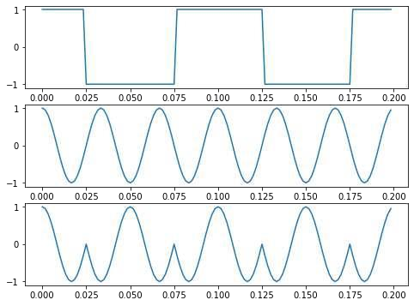

plt.plot(EbN0dB_list, BER, "-", EbN0dB_list, BER, "go") plt.axis([0, 14, 1e-7, 0.1])

plt.xscale('linear') plt.yscale('log') plt.grid() plt.xlabel("EbN0 in dB")

plt.ylabel("BER") plt.title("BER in BPSK")

plt.show()

## OUTPUT WAVEFORMS:

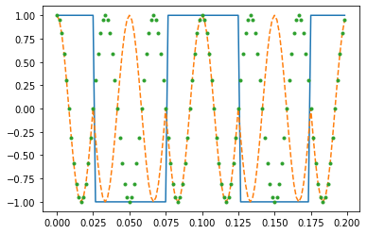

**RESULT:**

Simulated the code and verified the output waveforms.

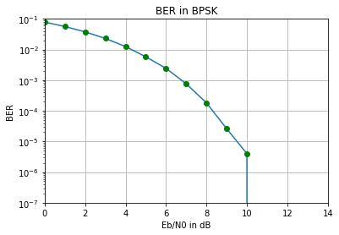

Date: 19.03.24 Experiment No: 05

## ERROR PERFORMANCE OF QPSK

**AIM:**

1. To generate a string of message bits.
2. To encode using QPSK with energy per symbol Es and represent it using points in a signal- space.
3. To simulate transmission of the QPSK modulated signal via an AWGN channel with variance N0/2 in both I-channel and Q-channel.
4. To detect using an ML decoder and plot the probability of error as a function of SNR per bit Eb/N0 where Es = 2Eb.

## THEORY:

**Quadrature Phase Shift Keying** QPSK is a variation of BPSK. The QPSK scheme is the most- widely used digital modulation technique, as it is used in wireless communications, such as WLANs/Wi- Fi and WiMAX standards, as well as many digital cellular mobile systems and TV broadcast satellite systems. Channel bandwidth depends on signaling rate .Two or more bits are combined then signal rate is reduced, the bandwidth required will be less. If two bits per symbol are transmitted, i.e. in each symbol we have 2 bits and if Phase shift keying is used then it is Quadrature Phase shift keying. QPSK the total 360-degree phase is divided into four phases.

i.e., 360/4 =90 degrees.

The four phases used are: 45°,135°,225°,315°. Mathematically QPSK can be represented as:

𝑠𝑖(𝑡) = √(2 s/T)cos(2Πfct+(2n-1)Π/4), 0 ≤ 𝑡 ≤ 𝑇 𝑤ℎ𝑒𝑟𝑒 𝑖 = 1,2,3,4

Wave forms and Signal space diagram are shown below.

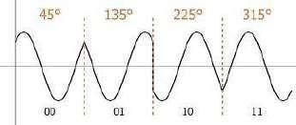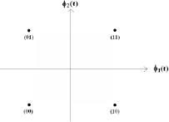

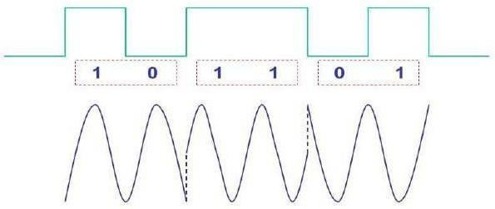

### QPSK Transmitter and receiver Block diagram

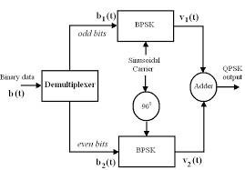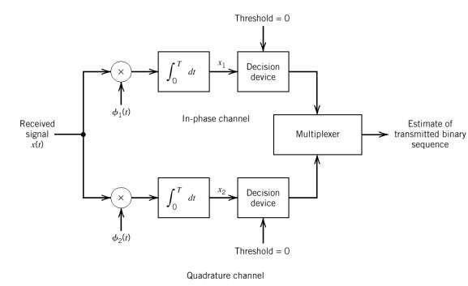

QPSK transmitter

QPSK receiver

## Bit Error Probability:

BER has been measured by comparing the transmitted signal with the received signal and computing the error count over the total number of bits. For any given modulation, the BER is normally expressed in terms of signal to noise ratio (SNR).

BER for QPSK is = 𝑒𝑟𝑓𝑐(√ 𝐸 )

2𝑁0

Since the symbol energy is twice the bit energy. E= 2Eb

𝑃𝑒 = 𝑒𝑟𝑓𝑐(√ 𝐸 )

𝑁0

## ALGORITHM:

QPSK generation

1. Generate random bit streams
2. Start FOR loop
3. Generate corresponding message signal. (bipolar form)
4. Multiply carrier 1 with odd bits of message signal and carrier 2 with even bits of message signal
5. Perform addition of odd and even modulated signals to get the QPSK modulated signal
6. Plot QPSK modulated signal.
7. End FOR loop.
8. Plot the binary data and carriers.
9. Add random noise to signal.
10. Based on the waveform decode the output.
11. Plot the input and output waveforms Bit Error Probability
12. Mention the no. of samples taken
13. Specify the range of Eb/N0
14. Find BER for each value of Eb/No and store it as an array.
15. Plot the graph BER vs Eb/No.

## PROGRAM:

# QPSK Modulation import numpy as np

import matplotlib.pyplot as plt

def cosineWave(f, overSamplingRate, nCycles, phase): fs = overSamplingRate * f



t = np.arange(0, nCycles*1/f, 1/fs) g = np.cos(2 * np.pi * f * t + phase) return list(g)

fm = 10

fc = 30

overSamplingRate = 20

fs = overSamplingRate * fc

x = np.random.rand(30) >= 0.5

str_x = [str(int(i)) for i in x] x = "".join(str_x)

print("Message string : {}".format(x))

message = [x[2*i : 2*(i+1)] for i in range(int(len(x)/2))] print("Message string grouped as combinations of 2 bits each :

{}".format(message))

mod_00 = cosineWave(fc, overSamplingRate, fc/fm, 3*pi/4) mod_01 = cosineWave(fc, overSamplingRate, fc/fm, pi/4) mod_10 = cosineWave(fc, overSamplingRate, fc/fm, -3*pi/4) mod_11 = cosineWave(fc, overSamplingRate, fc/fm, -pi/4)

modulated_signal = [] for i in message:

if i == '00':

modulated_signal = modulated_signal + mod_00 if i == '01':

modulated_signal = modulated_signal + mod_01 if i == '10':

modulated_signal = modulated_signal + mod_10

if i == '11':

modulated_signal = modulated_signal + mod_11

t = np.arange(0, (len(x)/2) * 1/fm, 1/fs) print(len(t), len(modulated_signal)) plt.figure(figsize = (28, 6)) plt.plot(t,

modulated_signal) plt.xlabel("Time") plt.ylabel("Amplitude") plt.title("Modulated signal") plt.grid(True) plt.show()



# Error performance of QPSK N = 500000

EbN0dB_list = np.arange(0, 50)

BER = []

for i in

range(len(EbN0dB_list)):

EbN0dB = EbN0dB_list[i] EbN0 = 10**(EbN0dB/10)

x = np.random.rand(N) >= 0.5

x_str = [str(int(i)) for i in x] x_str = "".join(x_str)

message = [x_str[2*i : 2*(i+1)] for i in range(int(len(x)/2))]

noise = 1/np.sqrt(2 * EbN0)

channel = x + np.random.randn(N) * noise received_x = channel >= 0.5

xReceived_str = [str(int(i)) for i in received_x] xReceived_str = "".join(xReceived_str)

messageReceived = [xReceived_str[2*i : 2*(i+1)] for i in range(int(len(x)/2))]

message = np.array(message) messageReceived = np.array(messageReceived)

errors = (message != messageReceived).sum() BER.append(errors/N)

print(BER)

plt.plot(EbN0dB_list, BER, "-", EbN0dB_list, BER, "go")

plt.xscale('linear') plt.yscale('log') plt.grid() plt.xlabel("EbN0 and B") ‘

plt.ylabel("BER") plt.title("BER in BPSK")

plt.show()

## RESULTS:

The simulations corresponding to QPSK modulator, detector and BER plot corresponding to QPSK are

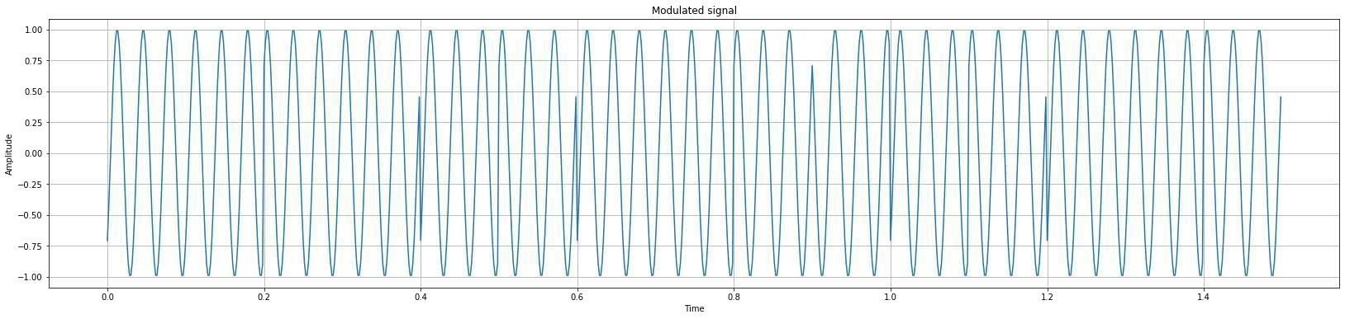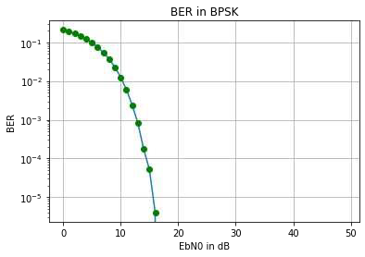

plotted herewith.

Message string: 101011111011101011011011101011

Message string grouped as combinations of 2 bits each: ['10', '10', '11', '11',

'10', '11', '10', '10', '11', '01', '10', '11', '10', '10', '11']

Date: 26.03.24 Experiment No:06

## PULSE SHAPING AND MATCHED FILTERS

**AIM:**

To

1. Generate a string of message bits.
2. Use root raised cosine pulse p(t) as the shaping pulse, and generate the corresponding baseband signal with a fixed bit duration Tb. You may use roll-off factor as α = 0.4.

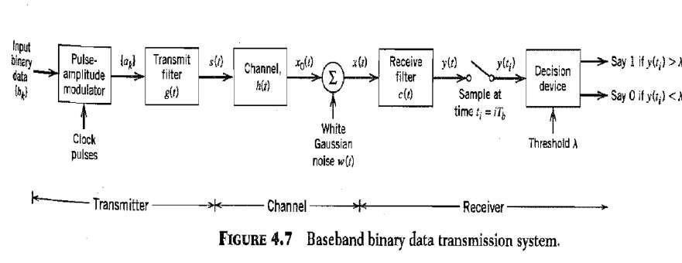

1. Simulate transmission of baseband signal via an AWGN channel
2. Apply matched filter with frequency response Pr (f) = P ∗ (f) to the received signal.
3. Sample the signal at *m*Tb and compare it against the message sequence.

## THEORY:

Inter symbol interference (ISI) is a form of distortion of a signal in which the symbol interferes with subsequent symbol.The spreading of the pulse beyond its allotted time interval causes it to interfere with neighboring pulses.ISI degrade the bit and symbol error rate performance in the presence of noise. The causes of ISI are multipath propagation and dispersion of channels. The baseband transmission system is as shown in figure 1.

Here,

𝑎𝑘 = {+1, 𝑖𝑓 𝑡*ℎ*𝑒 𝑠𝑦𝑚𝑏𝑜𝑙 𝑏𝑘 𝑖𝑠 1 − 1, 𝑖𝑓 𝑡*ℎ*𝑒 𝑠𝑦𝑚𝑏𝑜𝑙 𝑏𝑘 𝑖𝑠 0

𝑠(𝑡) = ∑

𝑘

𝑎𝑘𝑔(𝑡 − 𝑘𝑇𝑏)

The received filter output is written as

𝑦(𝑡) = 𝜇 ∑𝑘 𝑎𝑘𝑝(𝑡 − 𝑘𝑇𝑏) + 𝑛(𝑡).

Where μ- scaling factor and pulse p(t) is to be defined. At ith instant

𝑦(𝑡𝑖) = 𝜇 ∑

𝑘=−𝛼

𝑎𝑘𝑝[(𝑖 − 𝑘)𝑇𝑏] + 𝑛(𝑡𝑖)

𝑦(𝑡𝑖) = 𝜇𝑎𝑖 + ∑

𝑘=−𝛼,𝑘≠𝑖

𝑎𝑘𝑝[(𝑖 − 𝑘)𝑇𝑏] + 𝑛(𝑡𝑖)

The second term is due to ISI.

To avoid ISI Pulse shaping filters are used. Pulse shaping filter must be chosen carefully not to introduce inter symbol interference. The commonly used pulse shaping filters are –

* 1. Rectangular pulse shape: This pulse shape has poor spectral properties with high sidelobes.
  2. Sinc pulse shape: Theoretically, the sinc filter has ideal spectral properties, as the Fourier transform of a sinc function is an ideal lowpass spectrum. However, a sinc pulse is non-causal, hence not realizable.
  3. Raised-cosine pulse: This is a pulse widely used in practice. The pulse shape and the excess bandwidth can be controlled by changing the roll-off factor (0≤α≤1, where 0 means no excess bandwidth, and 1 means maximum excess bandwidth)

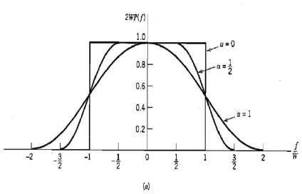

Figure 2. Raised cosine spectrum- frequency spectrum for different 𝛼 values

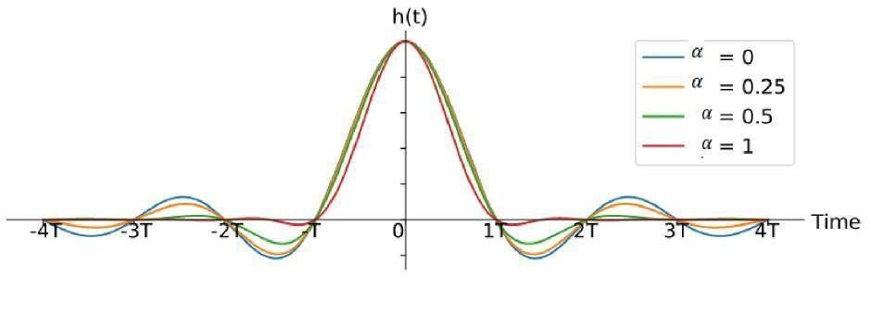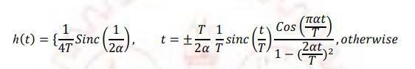

Figure 3. Impulse response of Raised cosine filter with various𝛼 values

(iv)

(v)

Root raised cosine pulse: It has a transfer function equal to square root of raised cosine filter. This filter satisfies Nyquist criteria. These filters are real valued and symmetric. It has its own matched filter.

Gaussian filter: The impulse response of this filter is a Gaussian function. Gaussian pulses

have good spectral properties.

## Matched filter:

A matched filter is a filter to provide maximum signal to noise ratio at the output. The Characteristic of the matched filter at the receiver should be complex conjugate of the one at the transmitter in order to fulfill Nyquist criteria. If an RRC filter used at the transmitter, the same filter can be used as it is in the receiver since RRC filter is its own matched filter. The impulse response of matched filter is h(t)= s(t-τ). Where s(t) is the input.

## ALGORITHM:

1. Specify the no. of symbols transmitted
2. Specify the no. of samples of transmitted signal.
3. Generate random binary data and convert it to NRZ format.
4. Oversample each bit by adding 8 samples.
5. Assume the number of taps, roll off rate (alpha) and sample period.
6. Generate a Raised Cosine filter.
7. Perform convolution between raised cosine filter and input signal.
8. Simulate an AWGN channel.
9. Send the convoluted signals through AWGN channel.
10. Generate output after convolution of noise affected signal with matched filter response.
11. Plot filter response.

## PROGRAM:

import numpy as np

import matplotlib.pyplot as plt from scipy import signal

num_symbols = 10

sps = 8

bits = np.random.randint(0, 2, num_symbols) # Our data to be transmitted, 1's and 0's x = np.array([])

for bit in bits:

pulse = np.zeros(sps)

pulse[0] = bit*2-1 # set the first value to either a 1 or -1

x = np.concatenate((x, pulse)) # add the 8 samples to the signal plt.figure(0)

plt.plot(x, '.-') plt.grid(True) plt.show()

# Create our raised-cosine filter num_taps = 101

beta = 0.35

Ts = sps # Assume sample rate is 1 Hz, so sample period is 1, so *symbol* period is 8 t = np.arange(-50, 51) # remember it's not inclusive of final number

h = 1/Ts*np.sinc(t/Ts) * np.cos(np.pi*beta*t/Ts) / (1 - (2*beta*t/Ts)**2) plt.figure(1)

plt.plot(t, h, '.')

plt.grid(True) plt.show()

x_shaped = np.convolve(x, h) plt.figure(2) plt.plot(x_shaped, '.-') for i in range(num_symbols):

plt.plot([i*sps+num_taps//2+1,i*sps+num_taps//2+1], [0, x_shaped[i*sps+num_taps//2+1]]) plt.grid(True)

plt.show()

## RESULT:

The performance of raised cosine pulse shaping and matched filter are simulated.

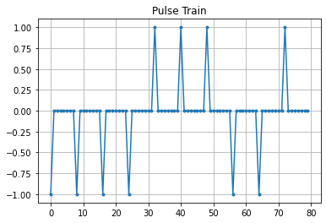

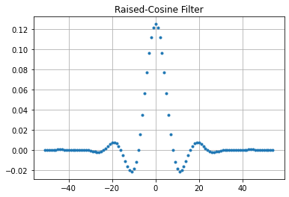

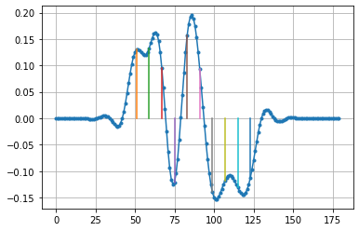

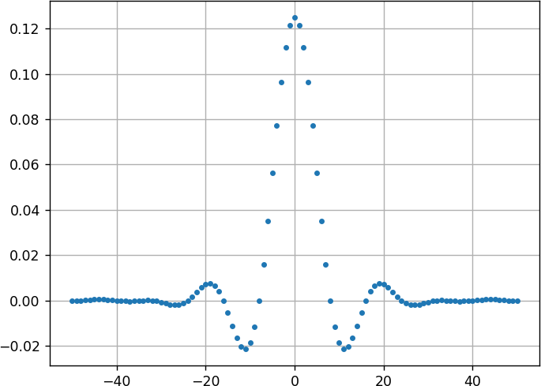

Date: 02.04.24 Experiment No: 07

## EYE DIAGRAM

**AIM:**

To:

1. Generate a string of message bits.
2. Use raised cosine pulse p(t) as the shaping pulse, and generate the corresponding baseband signal with a fixed bit duration Tb. You may use roll-off factor as α = 0.4.

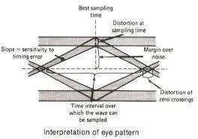

1. Use various roll off factors and plot the eye diagram in each case for the received signal.

Make a comparison study among them.

## THEORY:

An eye diagram is used to evaluate high speed data quality. An eye diagram is measured in the time domain. An eye pattern is a pattern displayed on the screen of a cathode ray oscilloscope (C.R.O.). The shape of this pattern resembles the shape of the human eye and therefore, it is called an eye pattern. The eye pattern is a practical way to study Inter symbol interference (ISI) and its effects on a PCM or data communication system. The interior region of the eye pattern is called the eye-opening. The eye pattern provides a great deal of information about the performance of the system.

30

**ALGORITHM:**

* 1. Specify the no. of symbols
  2. Specify the no. of samples.
  3. Generate random binary data and convert it to NRZ format.
  4. For each bit add 8 samples.
  5. Assume the number of taps, roll off rate (beta) and sample period.
  6. Create Raised Cosine filter.
  7. Perform convolution between raised cosine filter and input.
  8. Simulate an AWGN channel.
  9. Send the convoluted signals through AWGN channel.
  10. Perform convolution with matched filter response output of AWGN channel.
  11. Obtain the output.
  12. Generate eye diagram
  13. Obtain eye pattern for various roll off rates.

## PROGRAM:



import matplotlib.pyplot as plt

import numpy as np

def get_filter(T, rolloff):

def rc(t, beta):

# Simplified raised cosine function without error handling

return np.sinc(t) * np.cos(np.pi * beta * t) / (1 - (2 * beta * t) ** 2)

# Return the lambda function as the filter

return lambda t: rc(t / T, rolloff)

T = 1 # Time period

Fs = 100 # Sampling frequency

g = get_filter( T, 1)

binary_sequence = np.random.randint(0,2, size=50) # Generating random binary data

j = binary_sequence * 2 - 1 # NRZ

t = np.arange(-2 * T, (len(j) + 2) * T, 1 / Fs)

y = sum(j[k] * g(t - k * T) for k in range(len(j))) # Convolution

fig, ax = plt.subplots(2, 2, figsize=(20, 10))

ax[0][1].plot(t, y)

ax[0][1].set_title("Pulse Shaping")

x = np.arange(-T, T, 1 / Fs)

for i in range(2 * Fs, len(y) - 3 * Fs, Fs):

ax[1][1].plot(x, y[i:i + 2 * Fs], 'red')

ax[1][1].set_title("Eye Diagram")

ax[0][0].step(np.arange(len(binary_sequence)), binary_sequence)

ax[0][0].set_title("Binary Message")

t_impulse = np.arange(-5, 5, 0.01)

ax[1][0].plot(t_impulse, g(t_impulse))

ax[1][0].set_title("Impulse Response RC")

plt.show()

32

33

## RESULT:

The eye diagram for various roll off rate is simulated.

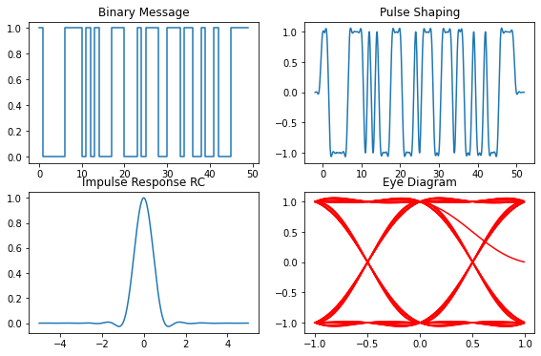

Date: 09.04.24 Experiment No: 08

## PERFORMANCE OF WAVEFORM CODING USING PCM

**AIM**:

To:



1. Generate a sinusoidal waveform with a DC offset so that it takes only positive amplitude value.
2. Sample and quantize the signal using a uniform quantizer with number of representation levels L. Vary L. Represent each value using decimal to binary encoder.
3. Compute the signal-to-noise ratio in dB.
4. Plot the SNR versus number of bits per symbol. Observe that the SNR increases linearly.

## THEORY:

Pulse code modulation is a method that is used to convert an [analog signal into a](https://www.elprocus.com/analog-to-digital-adc-converter/) [digital signal](https://www.elprocus.com/analog-to-digital-adc-converter/) so that a modified analog signal can be transmitted through the digital communication network. PCM is in binary form, so there will be only two possible states high and low (0 and 1). The Pulse Code Modulation process is done in three steps Sampling, Quantization, and Coding.

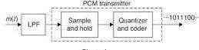

Low pass filter is used as an anti-aliasing filter. A Pulse Code Modulator circuit consists of Sample and Hold circuit, Quantizer and Encoder**.** The output will be in te form of ‘1’s’ and ‘0’s’. Sample and Hold circuit helps to collect the sample data at instantaneous values. Quantizer reduces the excessive bits and confining the data. The sampled output is fed to Quantizer. Encoder designates each quantized level by a binary code.

For PCM the quantization noise depends on no. of Quantization levels. The signal to quantization ratio of an n bit PCM system is given by

SNR=6n+1.8dB

SNR increases as number of bits *n* increases.

## ALGORITHM:



* 1. Generate samples of a raised sine wave of frequency *f* = 1 Hz or 2*Hz*

*x*(*t*) = A *×* 1 + sin(2*πft*)

with a sampling rate *fs* = 16 samples per second. Note that the sampling rate is four times the Nyquist rate.

* 1. Quantize the samples using different uniform quantizer values. The levels of quantization should be powers of 2 i.e., N= 2L. The resultant quantized signal is denoted by *Xx *(*nTs*).
  2. Encode each quantized sample using binary code with number of bits *R* = log2(*L*). This results in the pulse-code modulated binary stream of the input.
  3. Given the binary string, it is possible to reconstruct back *Xx*x(*nTs*) by binary-to-decimal conversion followed by appropriate scaling. Plot original signal *x*(*t*) and reconstructed signal *Xxx*(*nTs*).
  4. Compute the signal-to-noise ratio (SNR) as given below:
  5. Signal Power Px = 1 /2 × (A/2)^2
  6. Noise Power Pn = 

8. SNR in dB = 10 𝑙𝑜𝑔 (𝑃𝑥 𝑃𝑛)

9. Verify that the SNR in dB varies linearly with the number of bits R used by the encoder.

## PROGRAM:

# Pulse Code Modulation (PCM)



import numpy as np

from numpy import pi

import matplotlib.pyplot as plt

# Message signalgeneration

fm = 100

dc_offset = 2

t = np.arange(0, 5/fm, 0.0001)

x = np.sin(2 * pi * fm * t) + dc_offset

plt.figure(figsize = (8,

6)) plt.plot(t, x) plt.xlabel("Time") plt.ylabel("Amplitude") plt.title("Message Signal") plt.grid(True)

plt.show()

# Sampling

fs = 30 *fm

t = np.arange(0, 5/fm, 1/fs)

xSampled = np.sin(2 * pi * fm * t) + dc_offset

plt.plot(t, xSampled, "bo-") plt.xlabel("Time") plt.ylabel("Amplitude") plt.title("Sampled message Signal") plt.grid(True)

plt.show()

# Quantization

L = 4

x_min = min(x) x_max = max(x)

quantizationLevels = np.linspace(x_min, x_max, L) xQuantized = []

qInput = np.linspace(x_min, x_max, 1000) qOutput = []

for i in qInput: for j in



quantizationLevels: if i <= j:

qOutput.append(j) break

for i in xSampled: for j in

quantizationLevels: if i <= j:

xQuantized.append(j

) break plt.figure(figsize = (12, 6))

plt.subplot(1, 2, 1) plt.plot(qInput, qOutput, "r- ") plt.xlabel("Input") plt.ylabel("Output")

plt.title("Quantizer Characteristics L = 8") plt.grid(True)

plt.subplot(1, 2, 2) plt.plot(t, xQuantized, "bo- ") plt.xlabel("Time") plt.ylabel("Amplitude")

plt.title("Sampled and Quantized message Signal") plt.grid(True)

plt.show()

qlevels = {} bit_no =

int(np.log2(L)) for i in range(L):

val = bin(i).replace('0b', "") if len(val) != bit_no:

bin_str = "0" * (bit_no - len(val))

bin_str = bin_str + val else:

bin_str = val qlevels[quantizationLevels[i]] = bin_str

xTruncated = [qlevels[i] for i in xQuantized] print("Pulse coded message : {}".format(xTruncated))

# Signal to Noise Ratio (SNR)



def power(lst):

P = 0

for i in lst:

P = P + i**2 return P/len(lst)

quantizationNoise = xQuantized - xSampled plt.plot(t, quantizationNoise) plt.xlabel("Time")

plt.ylabel("Noise") plt.title("Quantization Noise") plt.show()

snr = power(xSampled) / power(quantizationNoise) snrdB = 20 * np.log10(snr)

step_size = (x_max - x_min)/L noisePower = (step_size**2)/3

snrEqn = power(xSampled) / noisePower snrEqndB = 20 * np.log10(snrEqn) print("SNR : {}".format(snrdB))

print("SNR from equation : {} dB".format(snrEqndB))

## RESULT:

The PCM simulation corresponding to an analog signal is done and the quantization is done for various levels. The effect of quantization levels on SNR is also studied.

Pulse coded message: ['100', '101', '101', '110', '111', '111', '111', '111', '111',

'111', '111', '111', '110', '101', '101', '100', '011', '011', '010', '001', '001',

'001', '001', '001', '001', '001', '001', '010', '011', '011', '100', '101', '101',

'110', '111', '111', '111', '111', '111', '111', '111', '111', '110', '101', '101',

'100', '011', '011', '010', '001', '001', '001', '001', '001', '001', '001', '001',

'010', '011', '011', '100', '101', '101', '110', '111', '111', '111', '111', '111',

'111', '111', '111', '110', '101', '101', '100', '011', '011', '010', '001', '001',

'001', '001', '001', '001', '001', '001', '010', '011', '011', '100', '101', '101',

'110', '111', '111', '111', '111', '111', '111', '111', '111', '110', '101', '101',

'100', '011', '011', '010', '001', '001', '001', '001', '001', '001', '001', '001',

'010', '011', '011', '100', '101', '101', '110', '111', '111', '111', '111', '111',

'111', '111', '111', '110', '101', '101', '100', '011', '011', '010', '001', '001',

'001', '001', '001', '001', '001', '001', '010', '011', '011']

SNR: 43.92496604223551

SNR from equation: 46.689075023018624 dB

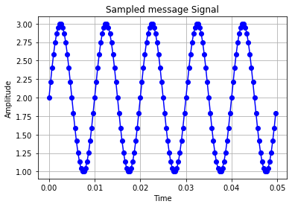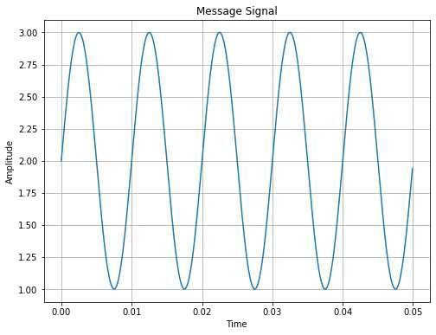

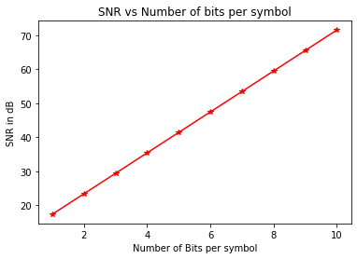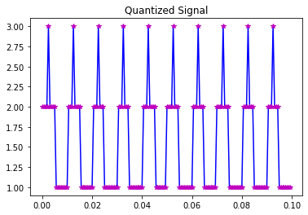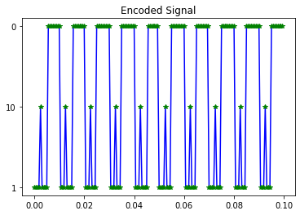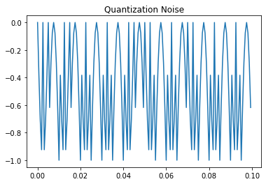

Date: 19.04.24 Experiment No: 09

# PART C

## FAMILIARIZATION WITH SOFTWARE DEFINED RADIO (HARDWARE AND CONTROL SOFTWARE)

**AIM:**

To:

1. Familiarize with an SDR hardware for reception and transmission of RF signal.



1. Familiarize how it can be interfaced with computer.
2. Familiarize with GNU
3. Familiarize available blocks in GNU Radio. Study how signals can be generated and spectrum (or power spectral density) of signals can be analyzed.

## THEORY:

The term “software-defined radio” (SDR) describes a technology in which the functions of a radio system’s hardware components are instead defined by software. SDR systems are more flexible than traditional radio systems. Software-defined radio is a type of radio communication in which the components that have traditionally been implemented in hardware (e.g. mixers, filters, amplifiers, modulators/demodulators, detectors, etc.) are instead implemented via software on a computer.

GNU Radio is a free & open-source software development toolkit that provides signal processing blocks to implement software radios. This can be used with readily-available low-cost external RF hardware to create software-defined radios, or without hardware in a simulation-like environment. It is widely used in research, industry, academia, government, and hobbyist environments to support both wireless communications research and real-world radio systems. It is a graphical user interface that comes with a comprehensive library of processing blocks that can be readily combined to make complex signal processing applications.

**HARDWARE:**

It consists of RTL-SDR dongle, antennas, USB port, connector wires and stands for Antennas.

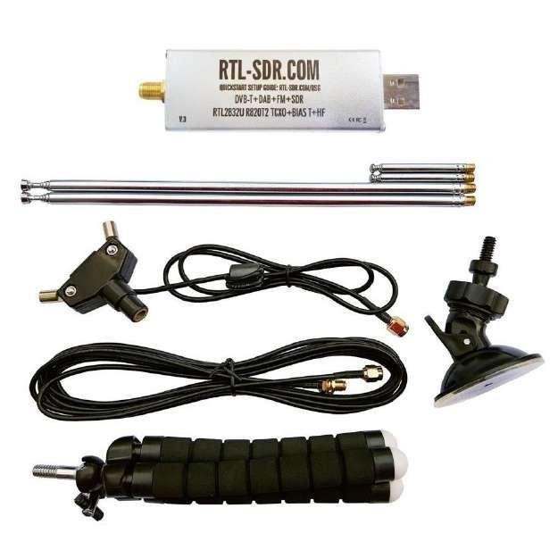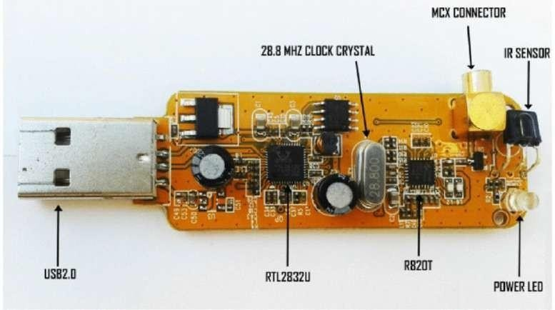

Figure 1. SDR Hardware Part Figure 1 shows the parts of RTL SDR Hardware set up.

Figure 2. Inside the RTL SDR Dongle

## INSTALLING SOFTWARE:

First step is download and install Ubuntu Desktop Go to terminal

Install the following software Gqrx, GNU radio Gqrx is a graphical SDR receiver. Update Ubuntu

sudo apt-get update

To install GNU radio at

sudo apt install gnuradio

To check whether RTL SDR is installed *type rtl tab* in command window and see the list. To install Gqrx

sudo apt-get install gqrx-sdr

Go to terminal and type *lsusb* to check whether the system has recognized the dongle. Please make sure that the system should recognize the dongle.

Can make sure this by typing the command *dmseg*

To receive a signal

Then type *“gqrx”* in terminal which will pop up a configurable menu Configure the SDR – select the I/O device

Now configure the receiver. Three panes appear in the screen. One is the receiver pane which shows receiver frequency, waterfall diagram etc. Figure 3 shows configurable receiver frequency and figure 4 shows corresponding waterfall diagram.

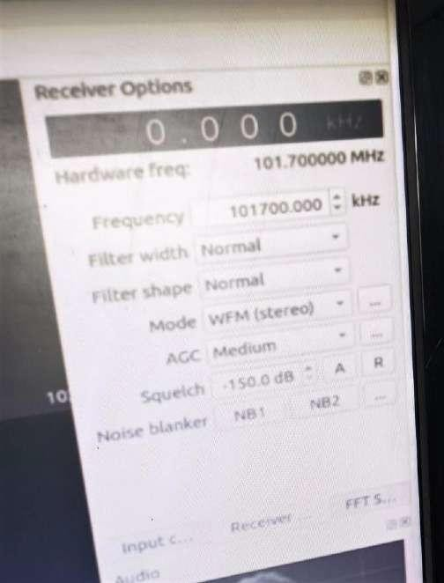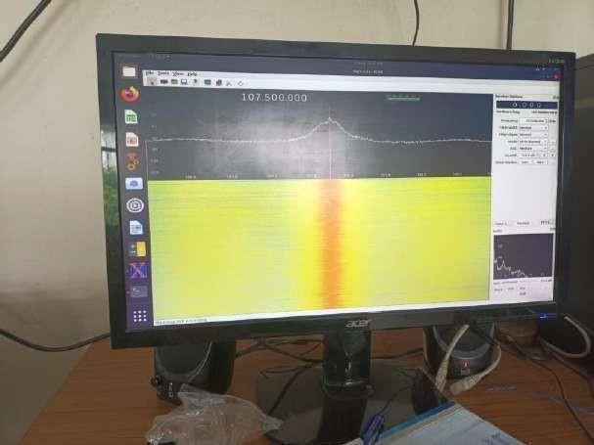

Figure 3. Frequency configuring window

Figure 4 .Water fall diagram

You can set the frequency in receiver pane. The bottom pane shows how audio is processed.

Select frequency, mode as WFM (wideband FM)

Then press the play button.

You can hear the corresponding radio station.

This part of the experiment helps you to verify your dongle and understand software defined radio.

You can try different radio stations:

* Radio Mango 91.9 FM.



Club 94.3 FM.

All India Radio Air Akashvani 102.3 FM. Radio Mirchi 104 FM.

Red 93.5 FM.

Air Rainbow 102.3 FM. Radio Gyan Vani 105.6 FM.

All India Radio AIR Kochi 107.5 FM.

**USING GNU RADIO:**

To open GNU radio in Ubuntu:

Open a terminal window using: Applications > Accessories >

Terminal. At the prompt type: *gnuradio-companion*.

It opens up as shown in figure 5

Figure 5. GNU radio

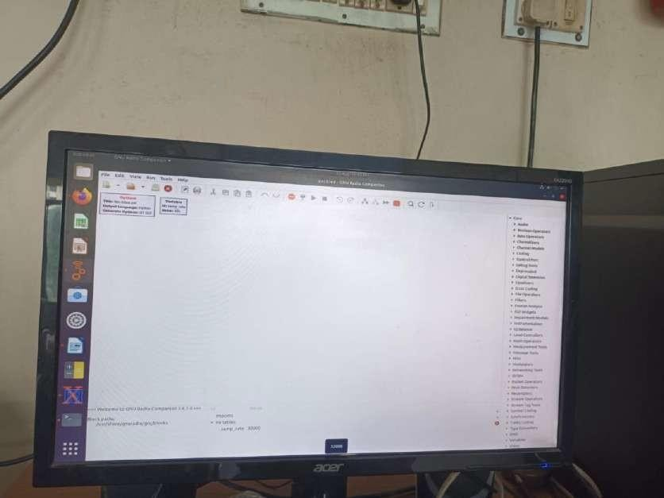

Message window

Work space

( You can also open GNU radio by pressing this icon.)

Options block

Variable window

The programs are developed in workspace.

GNU radio programs are called flow graphs. There are two blocks which you will find when you open GNU radio. They are Options block and Variable block

On opening Open Window as shown in figure 6, another window pops up.

In this window you can give title, id, copyright etc. There is a tab called output language. While compiling the flow graph, a program can be generated either in Python or C language by selecting the corresponding output language tab. From generate options select *QT GUI.*

The next block is Variable block. On variable block by default *the id is sampling rate*. We can change the sampling rate to 1 or 2 MHz as we are setting up digital radio.

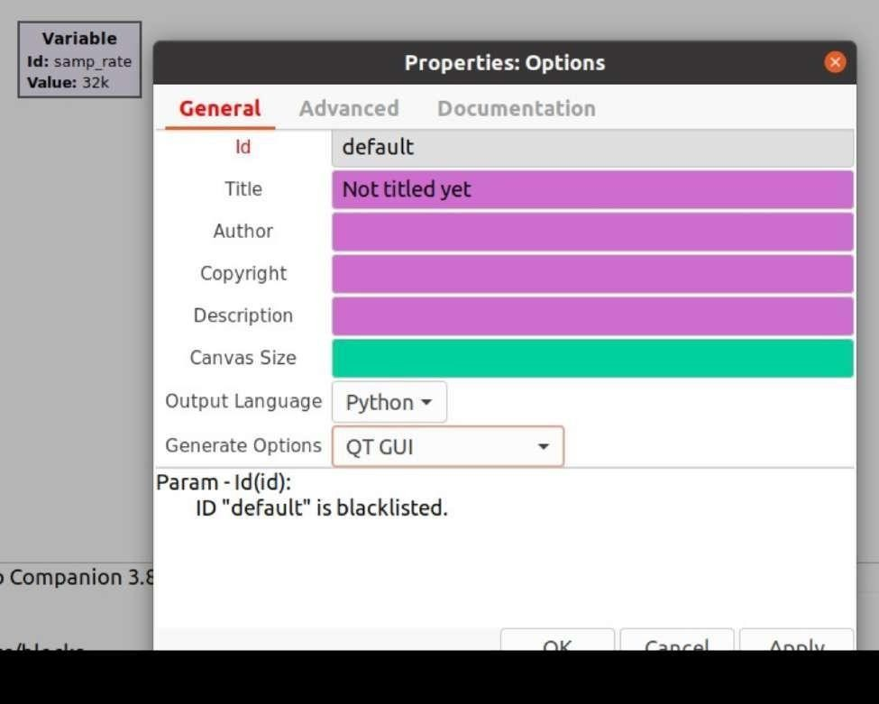

Figure 6. Options window

Figure 7



If there is an error in the code, the button marked in figure 7 is active. On clicking this button we will get errors. Then errors have to be rectified, and then only we can compile the program. Press the *RUN* button. There is an option called *GENERATE,* on pressing this, it will save as *.grc file.*

On the right side of the window is a list of the blocks that are available. By expanding any of the categories (click on triangle to the left) you can see the blocks available. Explore each of the categories so that you have an idea of what is available.

From the right side options, open the Waveform generators category and double click on the Signal Source. A Signal Source block will now appear in the main window. Double click on the block and the properties window will open. Adjust the settings as set to output a real valued 1 KHz sinusoid with amplitude of .5. Change the output type t float. Refer figure 8.

Figure 8 Setting Signal source

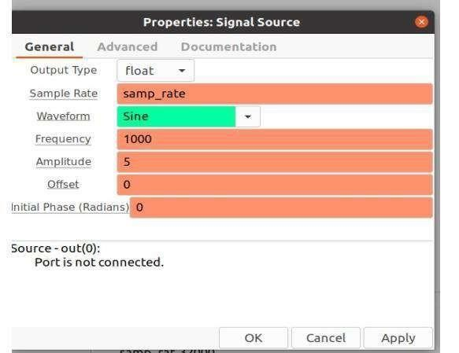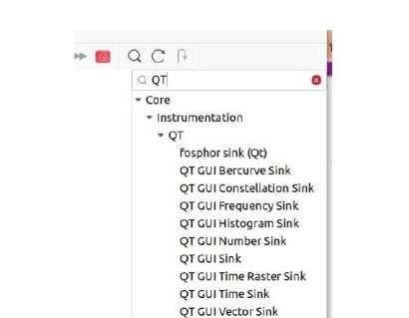

To view this wave we need one of the graphical sinks. Choose

Core→Instrumentation→ QT →QT GUI Time sink as shown in figure 9 and then double click on it.

Figure 9 QT sink

A box will appear. Make connections between them as shown in figure

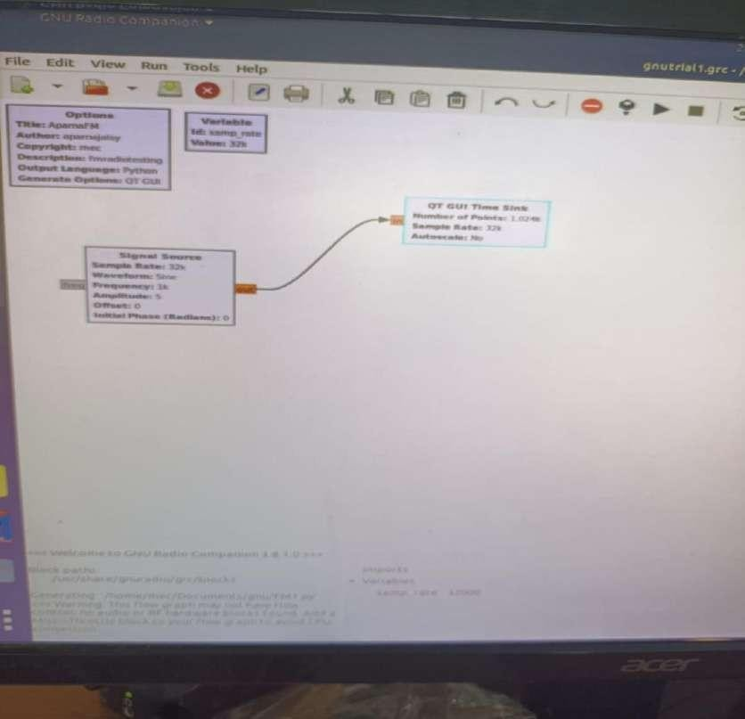

Figure 10.

In order to observe the operation of this simple system we must generate the flow graph and then execute it. Click first on the “Generate the flow graph” icon. A box will come up in which you enter the name of the file. Name this file: test1.grc and save. Click the

“Execute the flow graph” icon. A scope plot will open and several cycles of the sine wave are displayed as shown in figure 11.

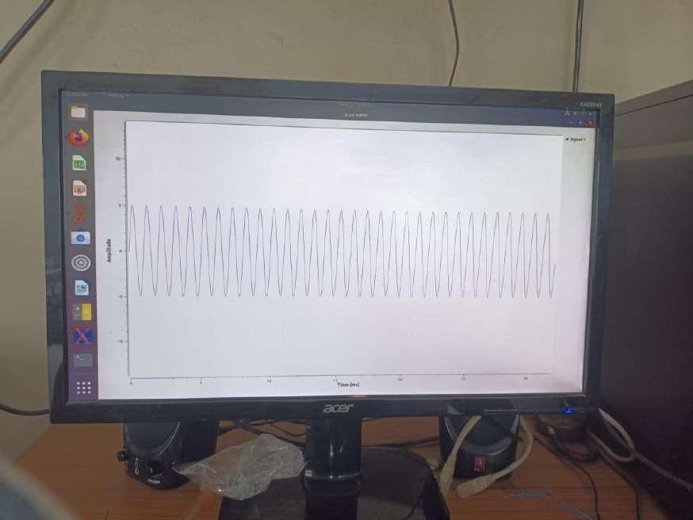

Figure 11.Waveform display

You can also display the frequency spectrum using QTGUI Frequency Sink, Audio sink waterfall Sink etc. The comnnections are as shown in figure 12 and results in figure 13

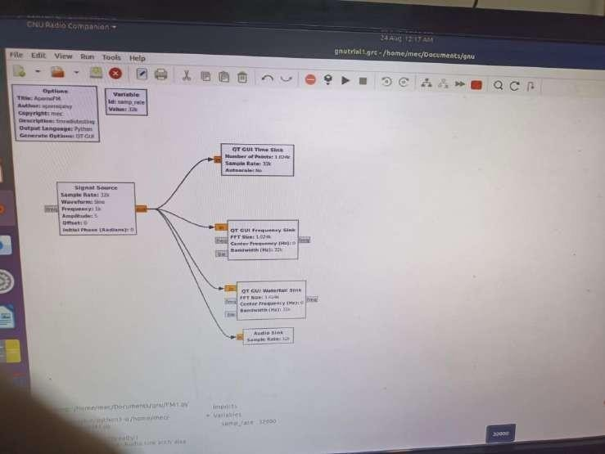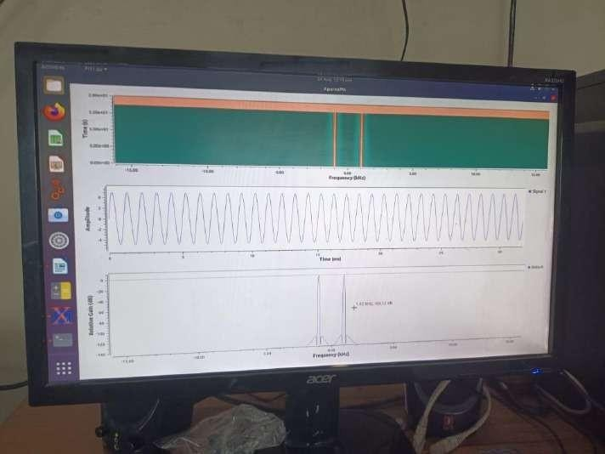

Figure 12

Figure 13

Similarly you can add multiply two different signals and display the results.

In addition to saving a “.grc” file with your flow graph, note that there is also a file titled “xxx. py”. Double click on this block. You will be given the option to Run or Display this file. Select Display. This is the Python file that is generated by GRC.

## RESULT:

Software Defined Radio is familiarized.



Date: 27.04.24 Experiment No: 10

## FM RECEPTION USING SDR

**AIM:**

To:

* 1. Receive digitized FM signal (for the clearest channel in the lab) using the SDR board.

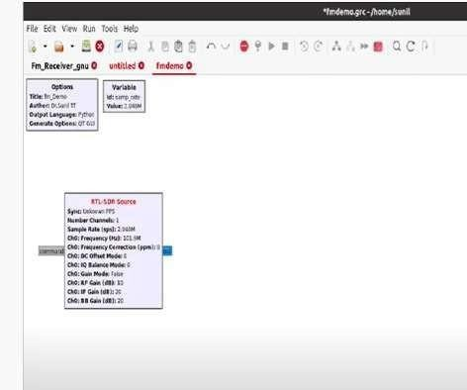

* 1. Set up an LPF and FM receiver using GNU Radio.
  2. Use appropriate sink in GNU Radio to display the spectrum of signal.
  3. Resample the voice to make it suitable for playing on computer speaker.

## PROCEDURE:

Start GNU radio. Set the Options and Variable windows. For Interfacing RTL SDR dongle, insert RTL SDR Source block as shown in Figure 1.

Figure 1

The simplest FM radio consists of few other elements like:

* Rational resampler
* Low pass filter
* WBFM demodulator
* Audio output - your PC's sound card

The setup for FM receiver is shown in Figure 2.

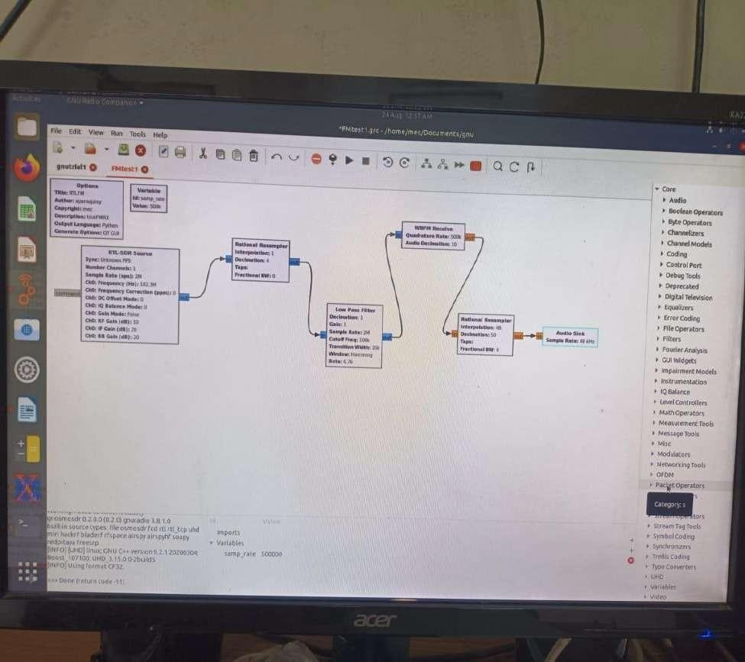

Figure 2

For the first rational resampler, set interpolation factor 1, decimation factor 4.

For Low pass filter, set decimation factor -1 Sample rate -2.04 MHz, Gain -1, Cut off frequency

- 100 KHz, Transition Width- 20 K, Window – Hamming, Beta – 6.76.

For WBFM Receive block, set the quadrature rate as 500 KHz and audio decimation as 10. For Second rational resampler, set interpolation factor 48 and decimation factor 50.

Audio sink sample is at 48KHz.

Now run the program. You can hear FM radio station you have set.

We can add slider and water fall diagram to view the spectrum. We can set FM range by QT GUI Range.

## RESULT:

FM receiver using Software Defined Radio is set up.